[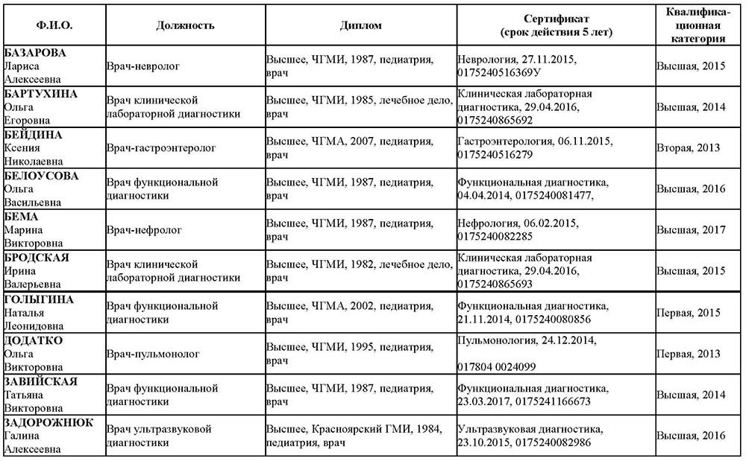](http://dkmc-chita.ru/files/price/doctors/opo1-1.jpg)  
[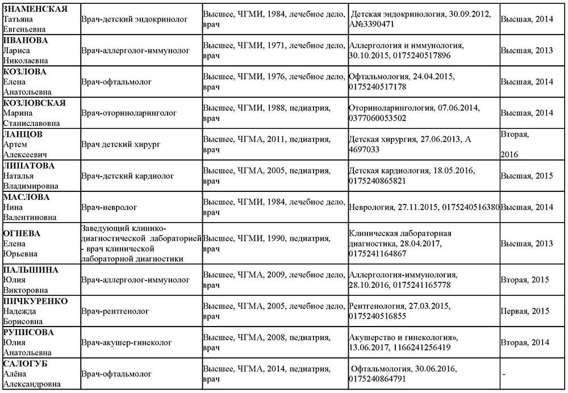](http://dkmc-chita.ru/files/price/doctors/opo2.jpg)  
[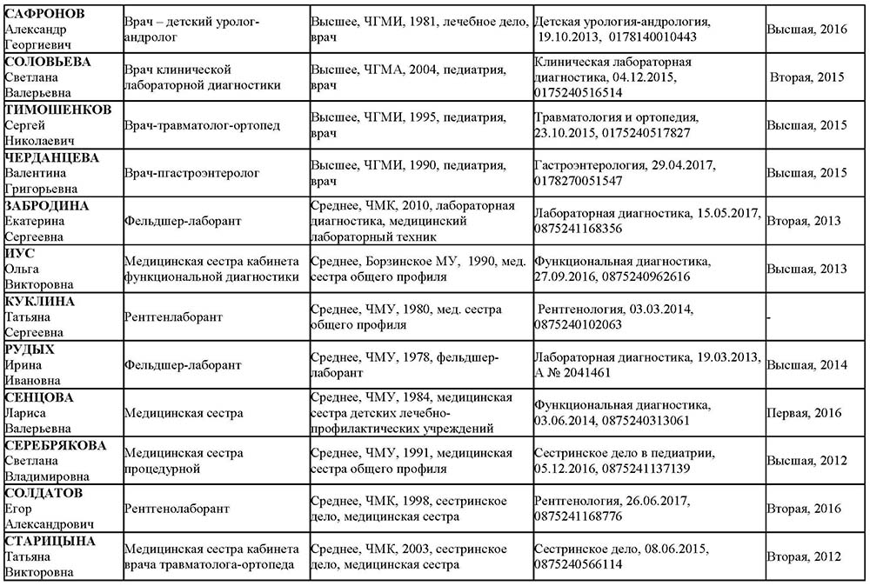](http://dkmc-chita.ru/files/price/doctors/opo3.jpg)  
[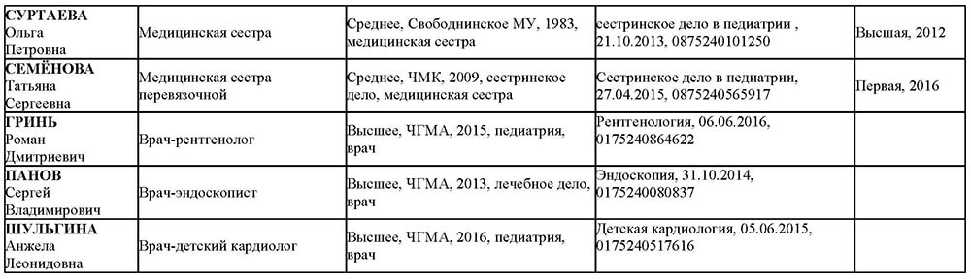](http://dkmc-chita.ru/files/price/doctors/opo4.jpg)

[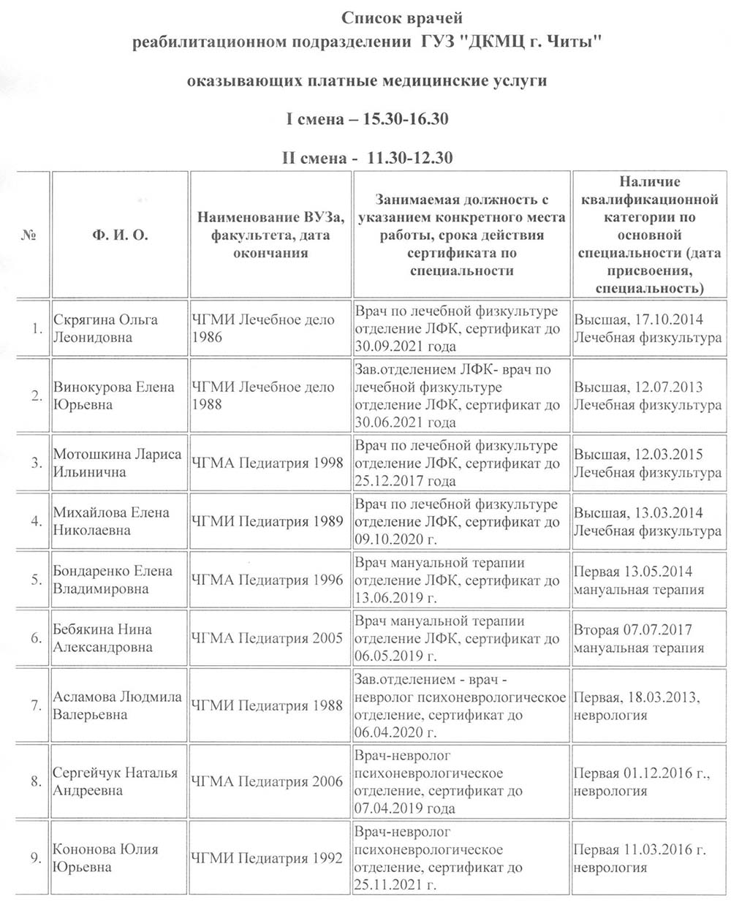](http://dkmc-chita.ru/files/price/doctors/fenix1.jpg)  
[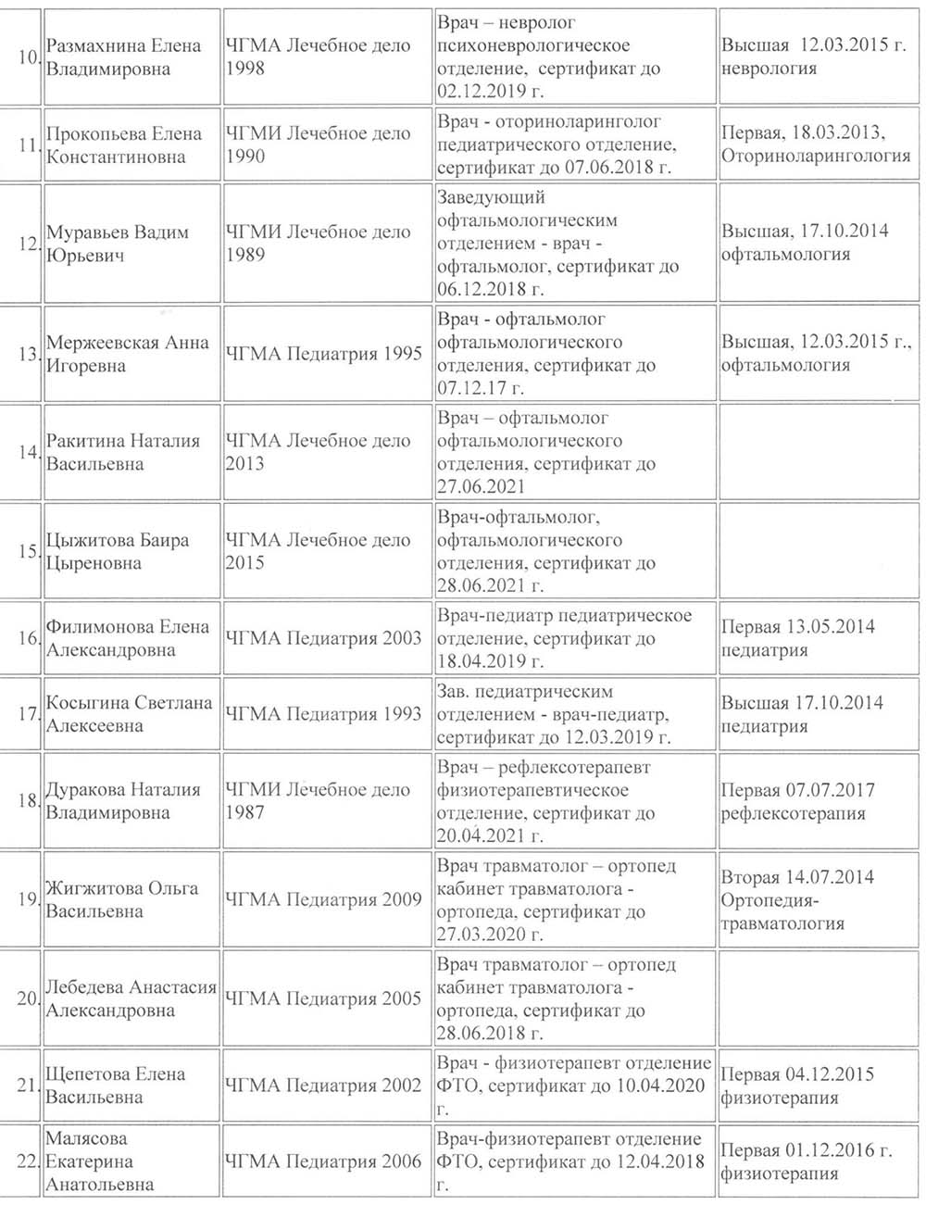](http://dkmc-chita.ru/files/price/doctors/fenix2.jpg)  
[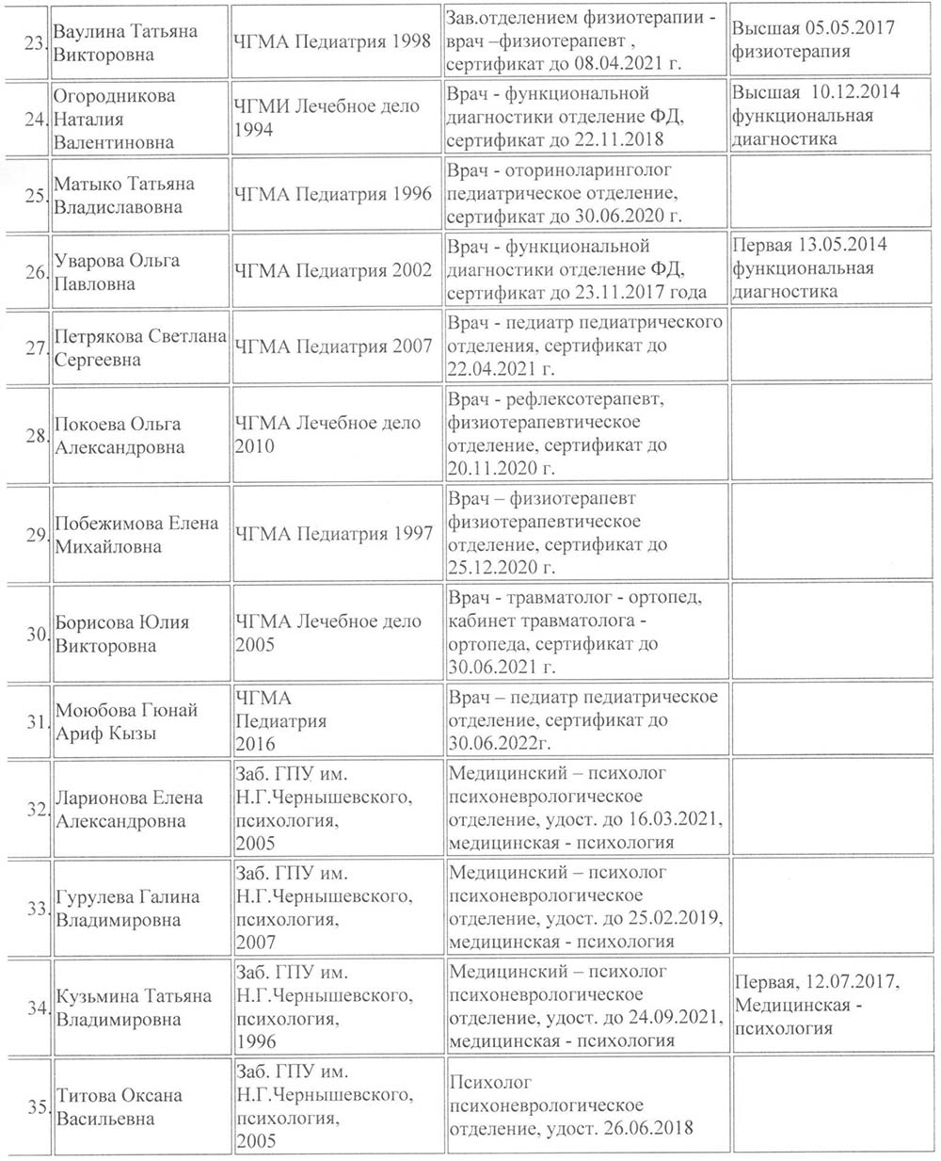](http://dkmc-chita.ru/files/price/doctors/fenix3.jpg)  
[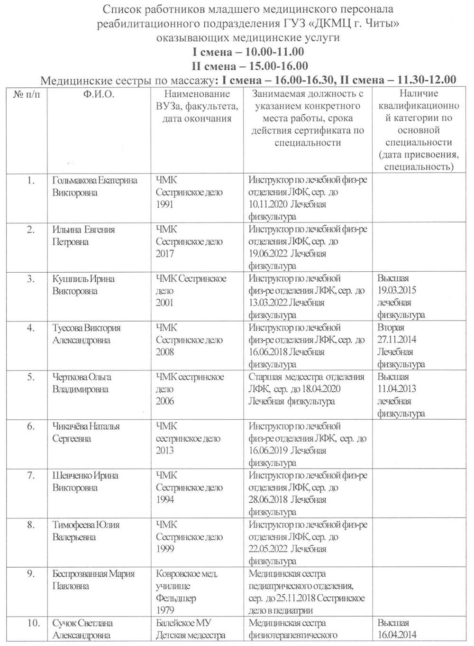](http://dkmc-chita.ru/files/price/doctors/fenix4.jpg) [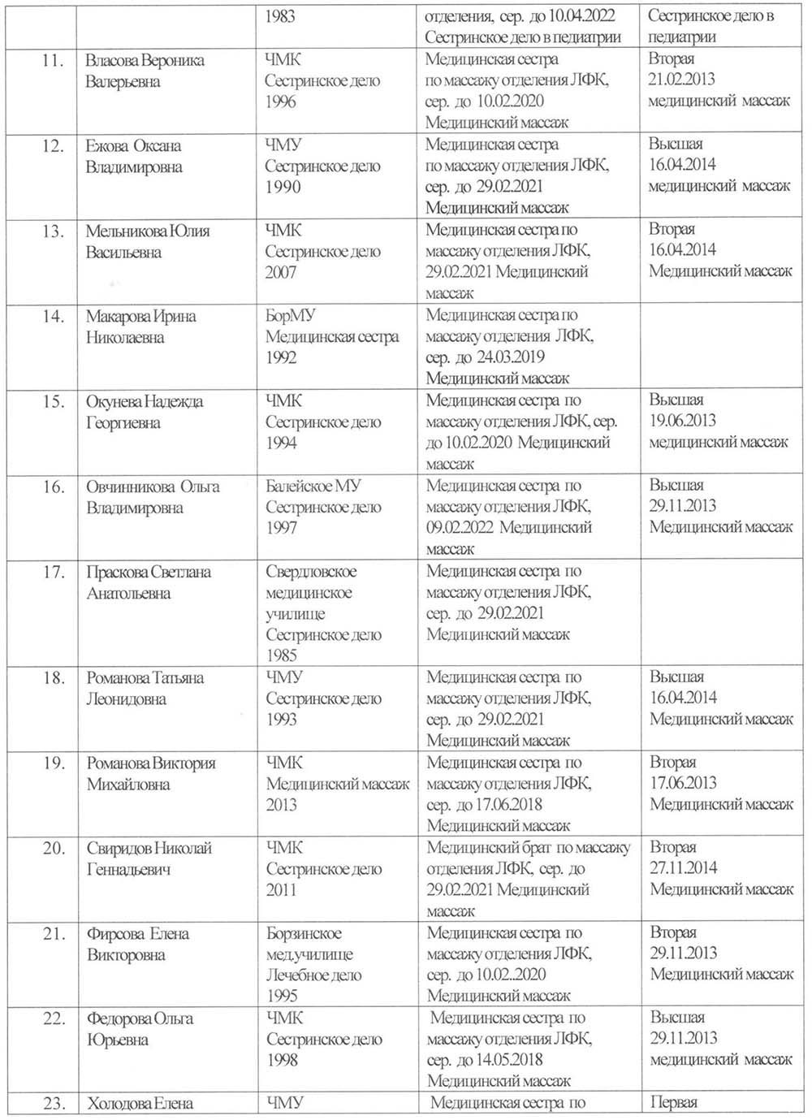](http://dkmc-chita.ru/files/price/doctors/fenix5.jpg) [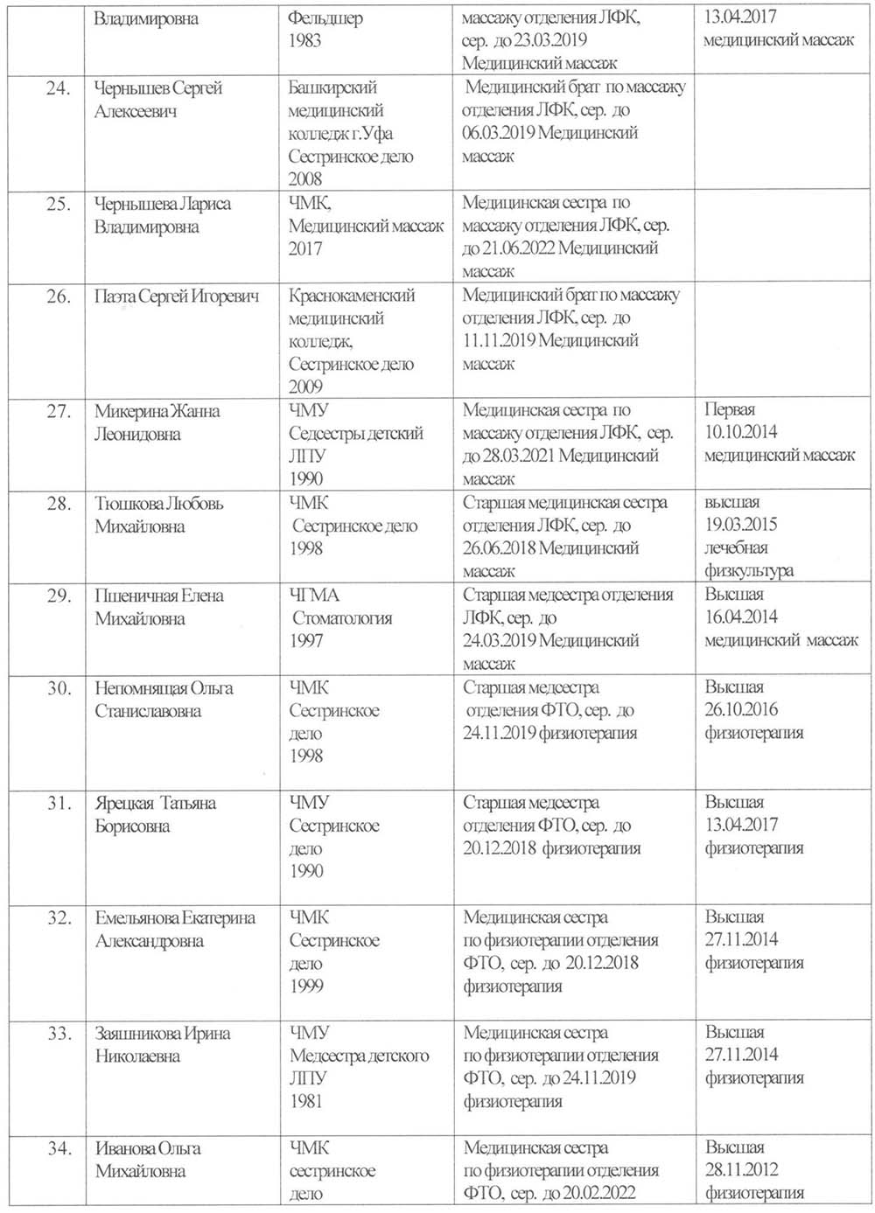](http://dkmc-chita.ru/files/price/doctors/fenix6.jpg) [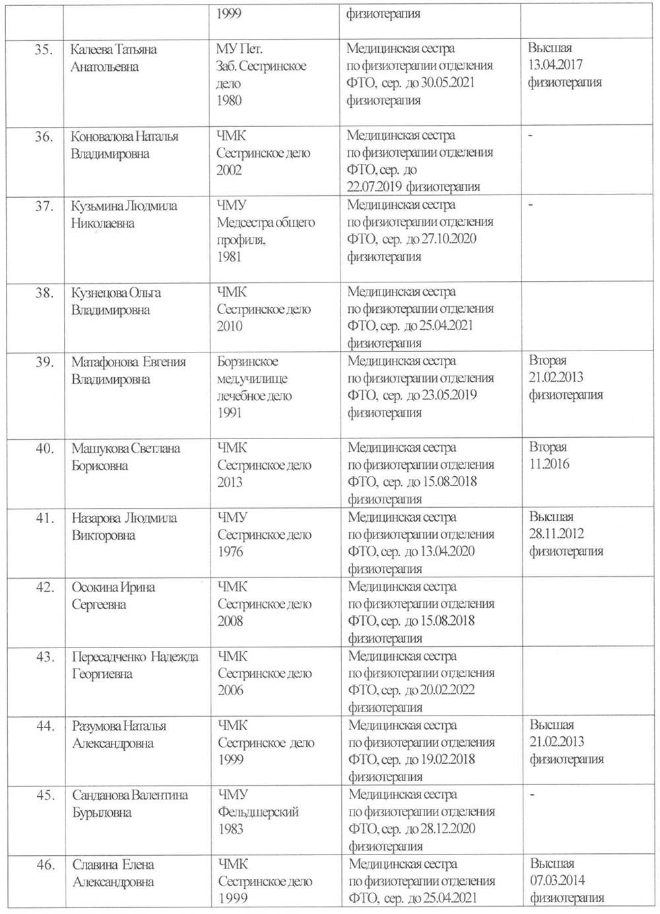](http://dkmc-chita.ru/files/price/doctors/fenix7.jpg) [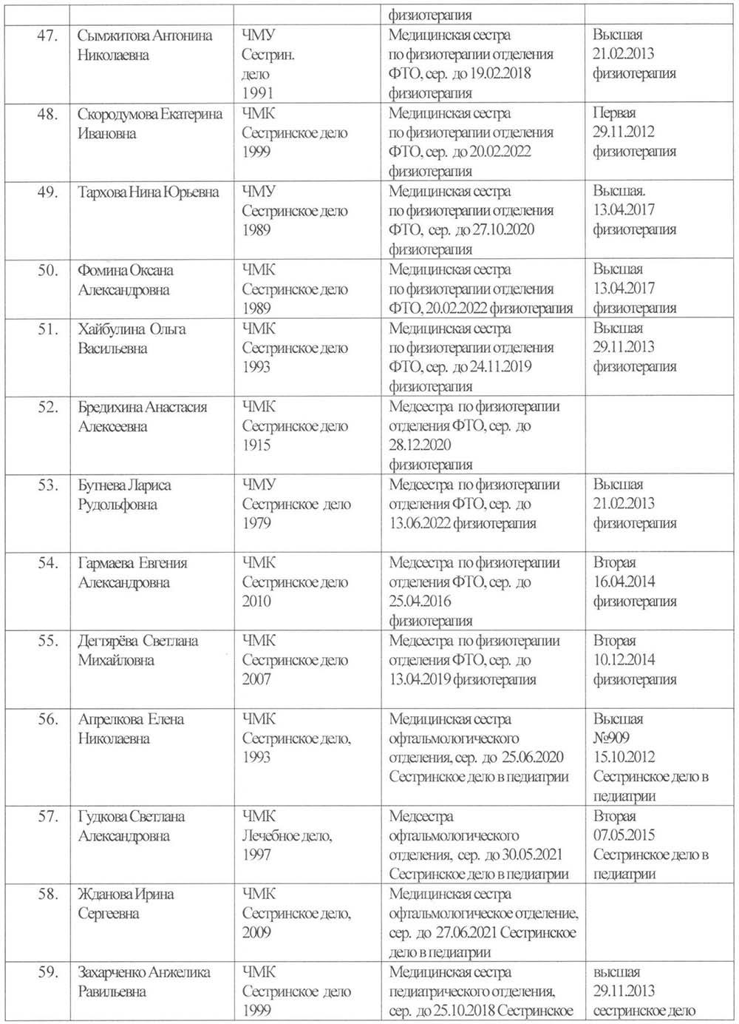](http://dkmc-chita.ru/files/price/doctors/fenix8.jpg) [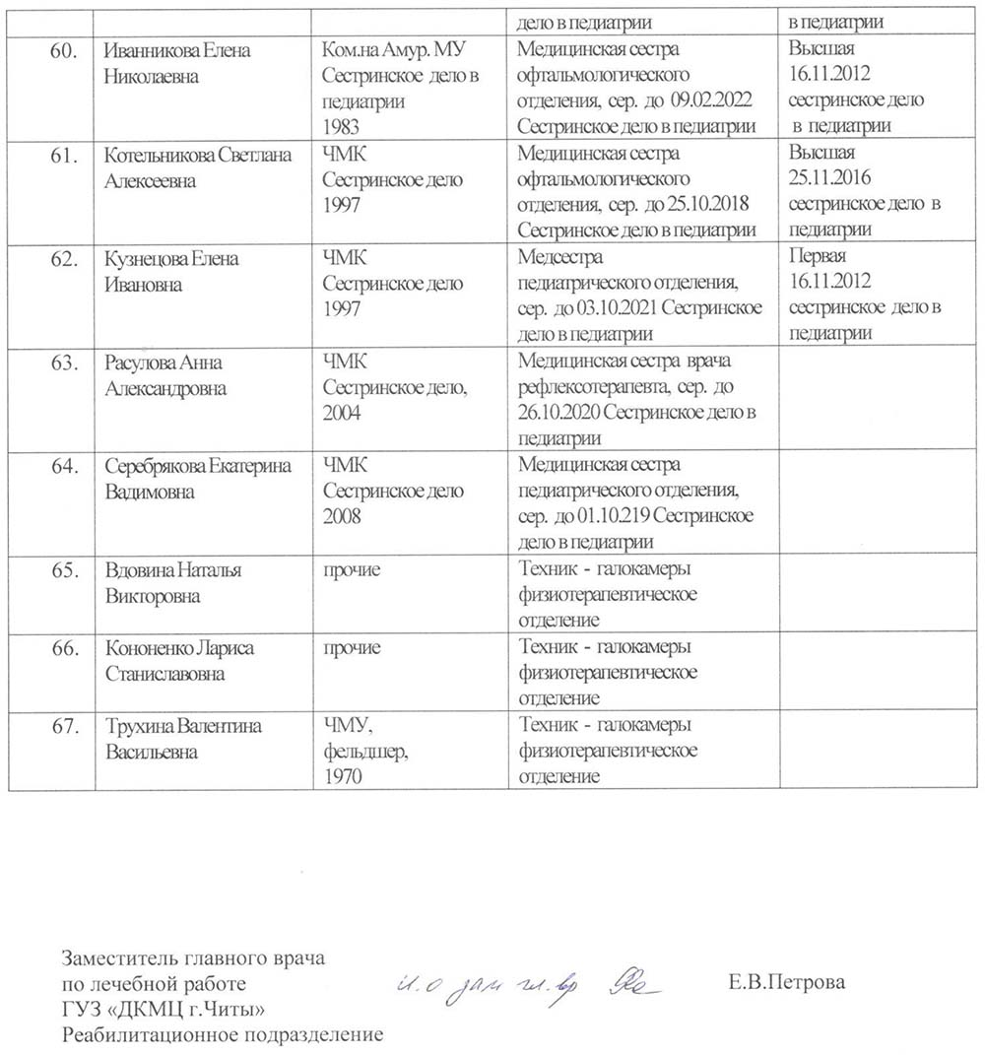](http://dkmc-chita.ru/files/price/doctors/fenix9.jpg)

[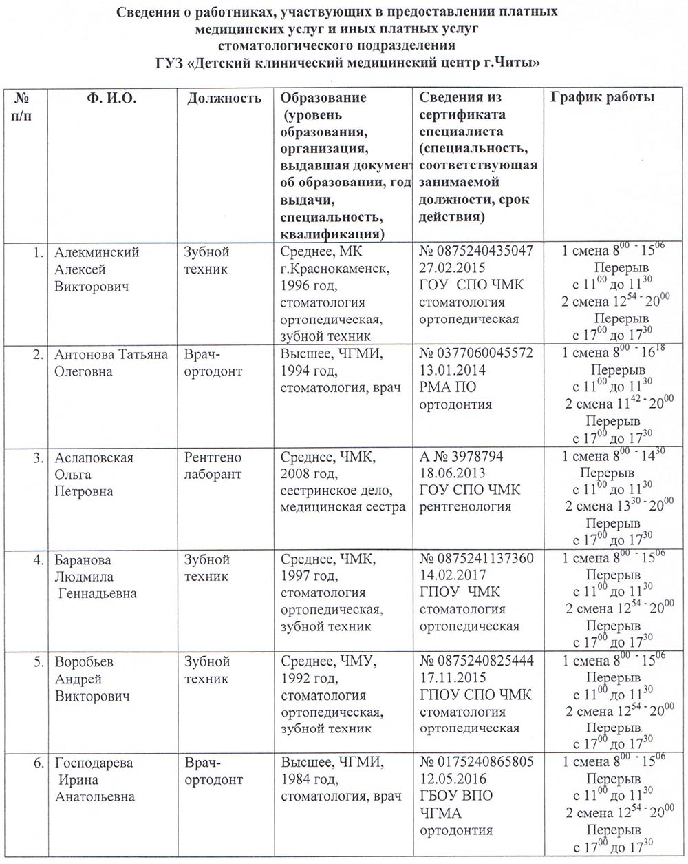](http://dkmc-chita.ru/files/price/doctors/sp1.jpg)

[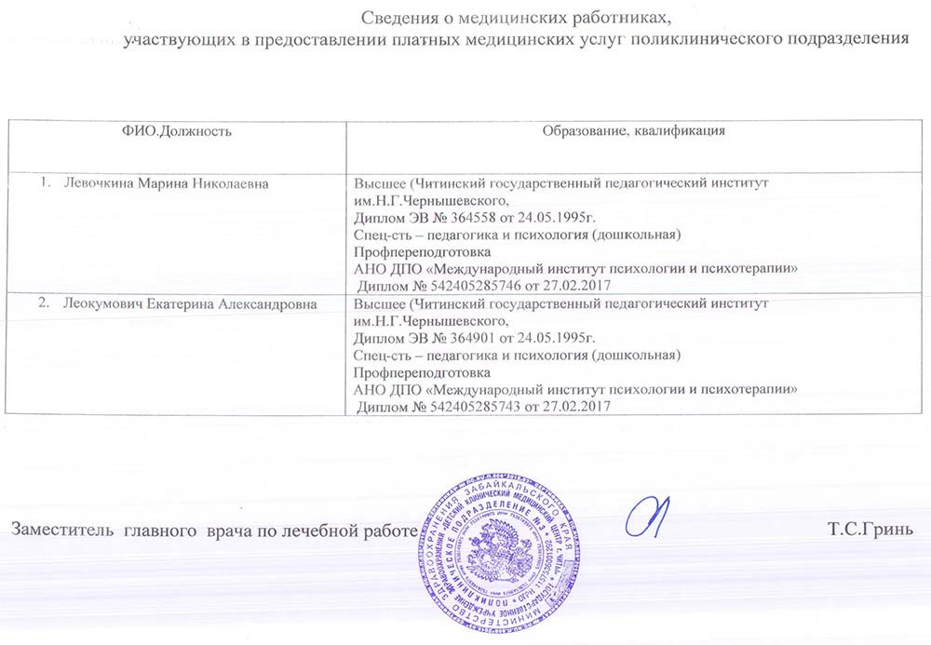](http://dkmc-chita.ru/files/price/doctors/pp3.jpg)

[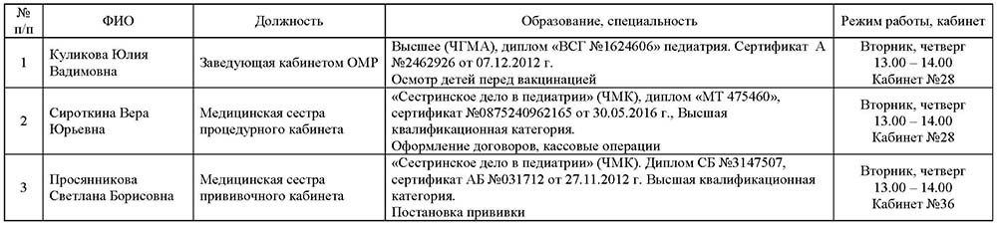](http://dkmc-chita.ru/files/price/doctors/pp5.jpg)

[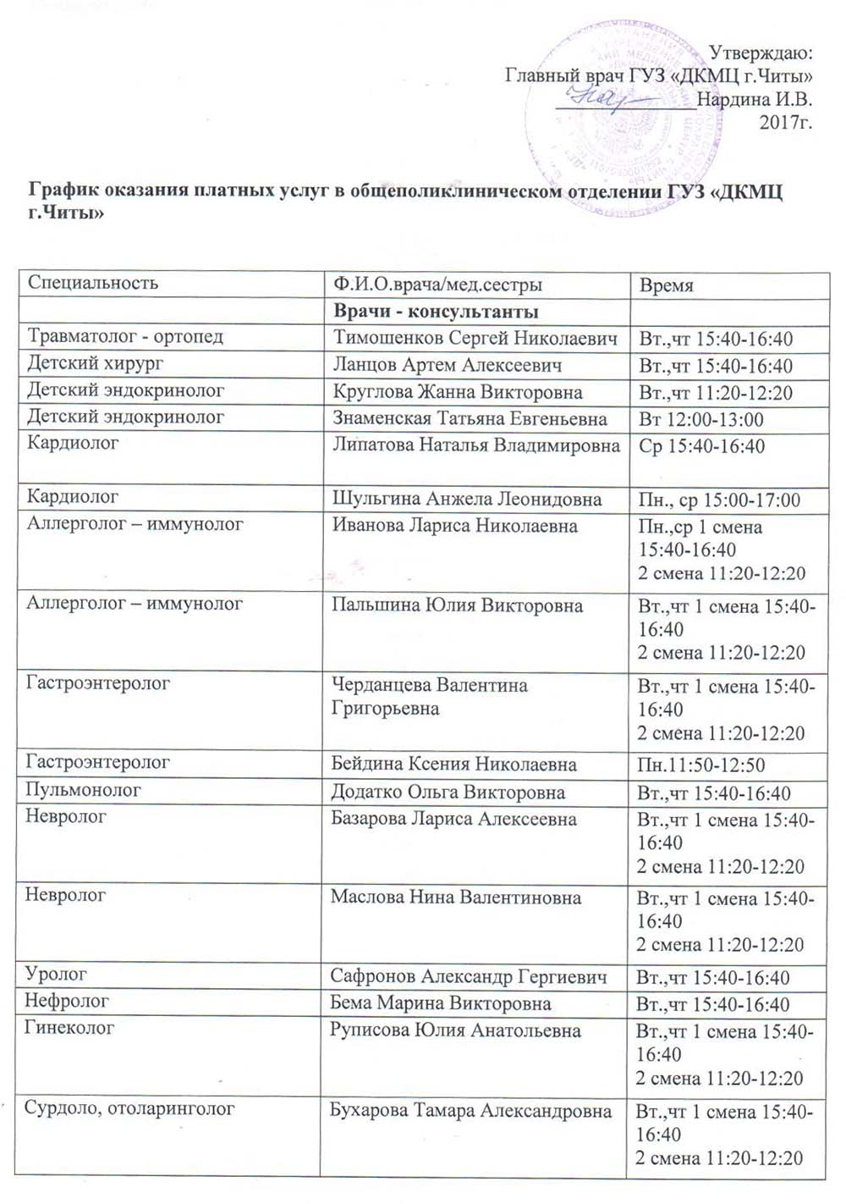](http://dkmc-chita.ru/files/price/doctors/graphopo1.jpg)  
[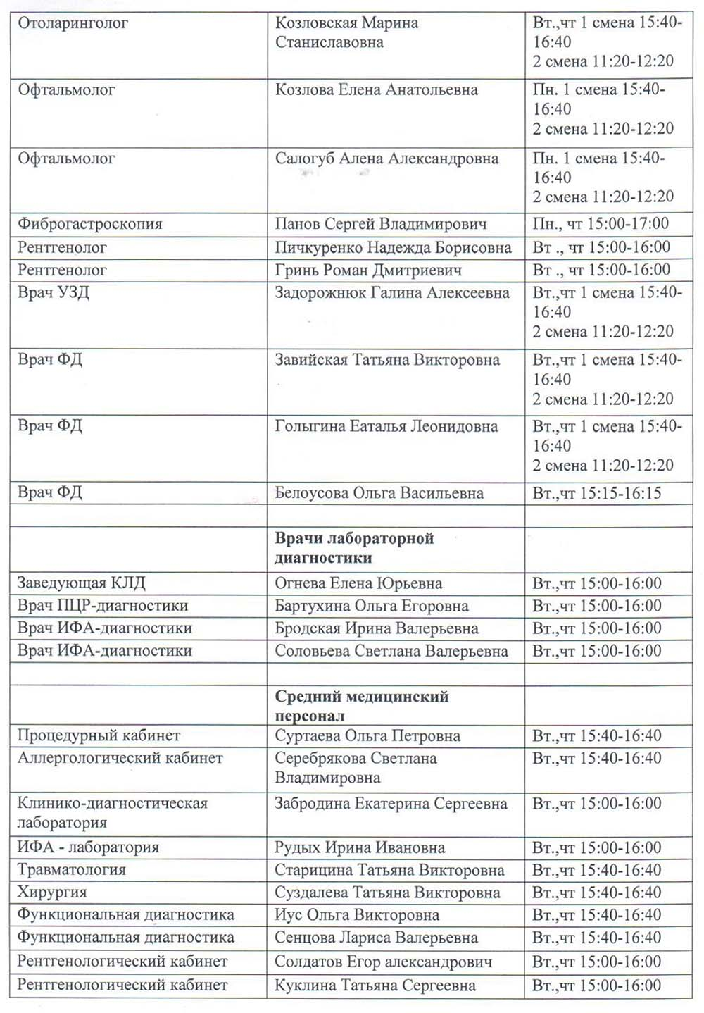](http://dkmc-chita.ru/files/price/doctors/graphopo2.jpg)